M.S. Ramaiah University of Applied Sciences – Faculty of Engineering & Technology (FET)
Smart EV Charging Bay and Thermal Runaway Protection
B. Tech. in Electrical and Electronics Engineering
Internship Work in
Department of Electrical and Electronics Engineering


Internship Project Team
Sl. No. | Reg. No. | Student Name
1 | 25ETEE003011 | C P Srivarshini
2 | 25ETEE003013 | Chethana M
3 | 25ETEE003017 | Jananya A G

Instructors: Mr. N. Madhu Sudhan/ Mr. Chetan Naik J
(Ramaiah Academy)

JULY– 2026

Faculty of Engineering and Technology

M. S. Ramaiah University of applied sciences

Bengaluru -560 054

Faculty of Engineering and Technology



Certificate
This is to certify that the Internship Work titled “Smart EV Charging Bay and Thermal Runaway Protection”, done at Ramaiah Academy Foundation, is a bonafide record of the work carried out by
Ms. C P Srivarshini Reg. No. 25ETEE003011
Ms. Chethana M Reg. No. 25ETEE003013
Ms. Jananya A G Reg. No. 25ETEE003017
in partial fulfilment of requirements for the award of B. Tech. Degree in Electrical and Electronics Engineering of M. S. Ramaiah University of Applied Sciences in the Department of Electrical and Electronics Engineering.

JULY – 2026

Mr. N. Madhu Sudhan/Mr. Chetan Naik. J Dr. T. N. Srikantha Dath
Lead Application Engineer Director (Q & C)
Ramaiah Academy Ramaiah Academy

Dr. S Nagraj Rao
HOD, Department of Electrical and Electronics Engineering

Declaration

The internship work is submitted in partial fulfilment of academic requirements for the B. Tech. Degree of M. S. Ramaiah University of Applied Sciences in the Department of Electrical and Electronics Engineering. This internship work is a result of our own work and is in conformance to the guidelines as laid out in the University Student Handbook.
Sl. No. | Reg. No. | Student Name | Signature
1. | 25ETEE003011 | C P Srivarshini
2. | 25ETEE003013 | Chethana M
3. | 25ETEE003017 | Jananya A G

JULY 2026

Acknowledgements

We take this opportunity to express our sincere gratitude and appreciation to Ramaiah University of Applied Sciences, Bengaluru for providing us an opportunity to carry out our internship work.
It brings a sense of privilege to associate this work with Ramaiah Academy Foundation. Working under them has been a precious opportunity. We are immensely thankful for trainer’s Mr. N Madhu Sudhan & Mr. Chetan Naik. J for their constant encouragement, inspiring ideas and mentoring, which reflects in the final images of this work.
We are grateful to the University and thank Dr. S Nagraj Rao, HOD of the Department of Electrical and Electronics Engineering for providing us with this opportunity, guidance, and encouragement throughout.
We would like to earnestly thank Dr. Sarat Kumar Maharana, the Dean, FET, and Dr. B S Dayananda, Associate Dean Academics, for facilitating academic excellence in the college that helped in completing this project.
We would also like to earnestly thank Prof. Kuldeep Kumar Raina, the Vice Chancellor, for facilitating academic excellence in the college that helped in completing this project.
We are thankful to the management of Ramaiah University of Applied Sciences for providing all the facilities and resources for the successful completion of the course.
Finally, we thank our parents, friends and all our well-wishers who have supported us in this endeavor.
The values of dedication, discipline, work ethics and patience that we have imbibed here will always remain the guiding force throughout our lives.

Abstract

The increasing cost of petrol and diesel has accelerated the global shift towards electric vehicles (EVs), which are widely regarded as a sustainable and economical alternative to conventional fuel-based transportation. Despite this growing interest, one of the major barriers to widespread EV adoption remains safety concerns, particularly those related to charging and battery performance. Numerous reported incidents of thermal runaway—where batteries overheat, release gases, and in severe cases catch fire or explode—have created hesitation among consumers. Addressing these safety concerns is therefore critical to building confidence in EV technology and encouraging its acceptance.
This project presents the design and testing of a prototype failsafe smart charging bay developed using an Arduino Uno microcontroller. The system integrates multiple sensors to continuously monitor for early warning signs of thermal runaway, including gas leakage, flame detection, and abnormal temperature rise. Charging sessions are authorized through an RFID-based button mechanism, ensuring that only registered users can initiate charging. Once authorized, the relay activates power flow to the charging point, while real-time sensor readings are displayed on an OLED screen. If hazardous conditions are detected, the system immediately triggers a “Thermal Event,” accompanied by a buzzer alarm and OLED warning message. Simultaneously, the relay is deactivated to cut power, thereby isolating the fault before it can escalate into a serious hazard.
Testing of the prototype under both normal and simulated hazardous conditions confirmed its effectiveness. Under normal conditions, the system operated reliably, authenticating RFID tags, displaying sensor data, and maintaining stable charging without false alarms. When hazardous conditions were introduced—such as artificially elevated gas concentration or flame exposure—the system responded within seconds by cutting power and issuing clear alerts. Unauthorized RFID tags were also correctly rejected, preventing unauthorized access to the charging bay. These results demonstrate that the prototype is capable of detecting early indicators of thermal runaway and responding autonomously without requiring user intervention.
In conclusion, this work demonstrates that affordable, microcontroller-based safety systems can play a significant role in improving EV charging safety. By providing real-time detection and immediate response to hazardous conditions, the prototype contributes to building consumer trust in EV technology.

Table of Contents

Certificate ……………………………………………………………………………………………………………….…(i)
Declaration………………………………………………………………………….……..................................(ii)
Acknowledgements……………………………………………………………..…………………………………….(iii)
Abstract …………………………………………………..……………………………………………………………..…(iv)
Table of Contents………………………………………….……………………………………………………..…. (v)

Chapter-1: Introduction ……………………………………………………………………………………………(1)

Chapter-2: Literature Review ……………………………………………………………………………………(3)

Chapter-3: Problem Statement………………………………………………………………………………….(5)

Chapter-4: Problem Solving ……………………………………………………………………………………..(7)

Chapter-5: Results and Discussions ………………………………………………………………………...(11)

Chapter-6: Conclusions and Future Scope………………………………………………………………..(14)

References ………………………………………………………………………………………………………………(17)

Appendices………………………………………………………………………………………………………………(18)

1.Introduction

Electrical Vehicles(EVs) are rapidly emerging as a visible alternative to conventional fuel based vehicles, driven by rising fuel prices and growing environmental concerns.However, the widespread EV adoption is being slowed down by persistent safety concerns, particularly around battery charging. Numerous incidents of charging mishaps, battery overheating, and thermal runaway have been reported globally, leading to fires and, in some cases, explosions. These incidents have been reported globally, leading to fires and, in some cases, explosions. These incidents have created a trust defecit among consumers, many of whom cite safety as a major reason for hesitating to switch to EVs.

Thermal Runaway is a chain reaction within battery cell where increasing temperature causess further chemical reactions that generate even more heat, eventually leading to fire or explosion if left unchecked. Since this process can begin subtly through minor ga sleakage,small temperature rises, or early detection is critical to preventing catastrophic failure.

This project proposes a smart EV Charging Bay with integrated Thermal Runaway Protection, designed to continuously monitor a charging battery for early warning signs of failure and to automatically isolate system if a hazard is detected. The system combines authentication, environmental and gas sensing,and automated relay based power cutoff to create a low cost, realiable safety mechanism suitable for both residentia; and public charging infrastructure.

Objectives of the Project:
- To design a safety that detects early indicators of battery thermal runaway during EV charging
- To implement automated power cutoff in the event of a detected hazard, minimizing risk to users and property.
- To provide real-time status monitoring via an OLED display and audible alerts.
- To restrict charging access to authorized users through button which also acts as start and stop button.
- To build a low-cost, scalable prototype using readily available embedded components (Arduino Uno).

2.Literature Review

A review of existing work in EV charging safety and battery thermal management reveals the following trends and gaps.

- Battery Management System (BMS): Most commercial EVs are equipped with an internal BMS that monitors cell voltage, current, and temperature. However, these systems are typically embedded within the vehicles itself and are not designed to provide external, station level monitoring or independent failsafe mechanism at charging bay.

- Gas and Smoke Detection in bn Battery Enclosures: Existing research has explored the use of gas sensors (e.g. ,MQ series sensors) to detect off-gassing a known early indicator of lithium ion battery degradation and thermal runaway since damaged cells release volatile gases before visible smoke or fire occurs.

- IoT Enabled Charging Stations: Several smart charging station prototypes incorporate connectivity(WiFi/Bluetooth)for remote monitoring and mobile alerts. However, many such systems focus primarily of billing, scheduling, or energy metering rather than safety-specific hazard detection.

- Temperature Monitoring: The surrounding temperature during any thermal runaway increases in order to indicate the change in surrounding we use a DHT11 sensor which will be displayed on OLED sensor.

Research Gap: While individual components of safety monitoring(gas detection, BMS, access control) exist in isolation across various systems, there is limited work on an integrated, low cost, standalone charging bay solution that combines authentication, real-time hazard detection, and automatic power isolation particularly one built on accessible hardware like the Arduino Uno without reliance on wireless modules.This project aims to fill that gap with integrated prototype.

3.Problem Statement

Despite the growing shift towards electric vehicles, safety incidents during charging — including battery overheating, gas leakage, and thermal runaway — continue to undermine consumer confidence. Most existing charging setups lack a dedicated, independent safety layer that can detect early warning signs of battery failure and respond autonomously, without relying on the vehicle's internal systems. There is a need for a standalone, affordable, and reliable safety mechanism at the charging bay level that can:

- Continuously monitor environmental indicators associated with battery thermal runaway — including hazardous gas emissions, the presence of open flame, and abnormal ambient temperature — using low-cost, readily available sensors.

- Detect early warning signs of failure before they escalate into a critical hazard, since thermal runaway typically progresses through detectable precursor stages (gas off-gassing, slight temperature rise) before visible fire or explosion occurs.

- Respond autonomously and immediately, cutting power to the charging point without requiring manual intervention, to minimize response time during a genuine emergency.

- Communicate system status clearly to the user through real-time visual and audible feedback, so that any hazardous condition is immediately apparent.
- Remain affordable and scalable, using accessible embedded hardware (such as the Arduino Uno platform) rather than complex or expensive proprietary safety systems, so that the solution can realistically be adopted across both residential and public charging infrastructure.

This project addresses this problem by designing and implementing a Smart EV Charging Bay with Thermal Runaway Protection using an Arduino Uno-based embedded system

4.Problem Solving

  - Design Approach
To tackle the safety challenges outlined in Chapter 3, the proposed solution uses a multi-layered safety architecture built around three primary stages: user authentication, continuous hazard monitoring, and an automated emergency response.
Instead of relying on an electric vehicle's internal Battery Management System (BMS), this system operates independently at the charging station itself. Controlled by an Arduino Uno, this localized safety layer works regardless of the specific vehicle model being plugged in, making it universally applicable across different EV platforms.
The design is guided by three core engineering principles:
- Redundancy: Rather than relying on a single detector, the system uses multiple independent sensors (gas, flame, and temperature) to eliminate single points of failure.
- Rapid Response: The hardware detects and reacts to hazardous conditions in real time, eliminating the dangerous delay of waiting for manual human intervention.
- Practicality and Cost-Effectiveness: By using accessible, off-the-shelf hardware, the overall design remains affordable and easy to deploy at scale in standard charging bays.

4.2 System Architecture and Workflow
During a typical charging cycle, the system moves through a continuous, deterministic operational workflow:

Stage 1: User Authentication
Charging cannot begin until a user presses the button. This button acts as start/stop button, which allows flow of current and also cuts flow of current.
Stage 2: Power Activation
Once button is pressed, the Arduino sends a signal to trigger a flow of current and
the led gets on this indicates the vehicle is charging.
Stage 3: Continuous Environmental and Hazard Monitoring
While power flows to the vehicle, the controller constantly polls its sensor array to catch early warning signs of thermal runaway:
- MQ Gas Sensor: Detects combustible gases that vent during early battery cell damage—a well-documented precursor to thermal runaway.
- MQ135 Gas Sensor: Monitors overall air quality and picks up broader chemical off-gassing, including ammonia, carbon dioxide, and benzene vapors.
- Flame Sensor: Detects infrared light emitted by open fire, allowing for instant flame recognition.
- DHT11 Sensor: Tracks ambient temperature and humidity within the bay to catch rapid heat buildup before catastrophic breakdown occurs.
The Arduino compares every incoming reading against calibrated safety thresholds established during initial system testing.
Stage 4: Real-Time Status Feedback
Throughout the session, an OLED display provides clear live feedback. It cycles through current environmental metrics (temperature, humidity, and gas levels) alongside general system statuses like "Charging in Progress", "All Systems Normal", or "THERMAL EVENT". This keeps users fully informed of both the charging progress and the immediate environment.
Stage 5: Automated Hazard Response
If any sensor breaches its safe limit, the system instantly halts operation and executes an emergency safety routine without needing human input:
- The active buzzer sounds a high-frequency audible alarm to alert nearby personnel.
- The OLED screen overrides its current display to broadcast a prominent "THERMAL EVENT DETECTED" emergency warning.
By taking human delay completely out of the loop, this immediate response prevents minor thermal faults from spiraling into full-scale battery fires.

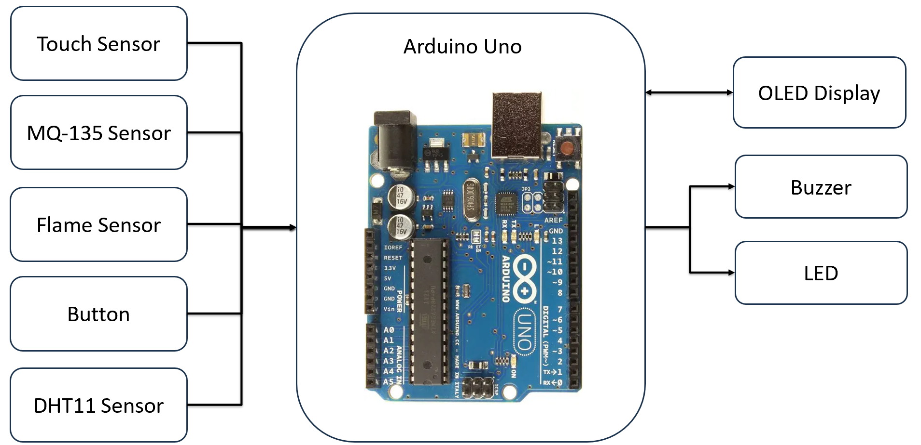

Fig1.Block Diagram

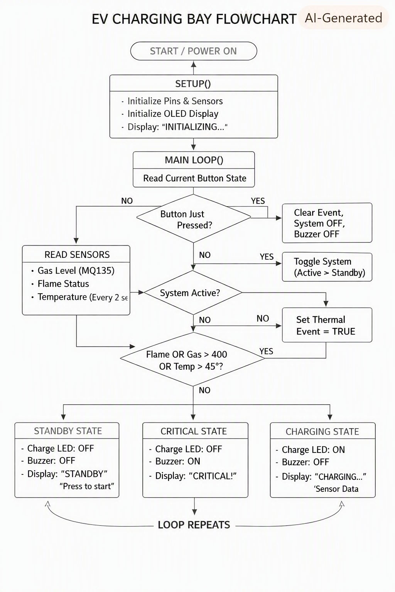

Fig2. Flowchart of the code

5.Results and Discussion

Results
The prototype was tested under both normal charging conditions and simulated hazardous conditions to evaluate its performance and safety response.

  - Normal Conditions:
    - The system successfully checked the working of a button.
    - Once the button was pressed, the led was on, indicating charging has begun.
    - Real-time sensor data (temperature, humidity, and gas concentration) was displayed on the OLED screen.
    - No false alarms were triggered, confirming stable operation under safe conditions.

  - Hazardous Conditions:
    - When gas concentration was artificially increased (to simulate battery off-gassing), the system detected the anomaly and triggered a “THERMAL EVENT” alert within seconds.
    - Similarly, when a flame source was introduced near the flame sensor, the system responded immediately by cutting off power deactivation.
    - The buzzer and OLED warning provided clear and immediate feedback, ensuring that the hazardous condition was communicated effectively.
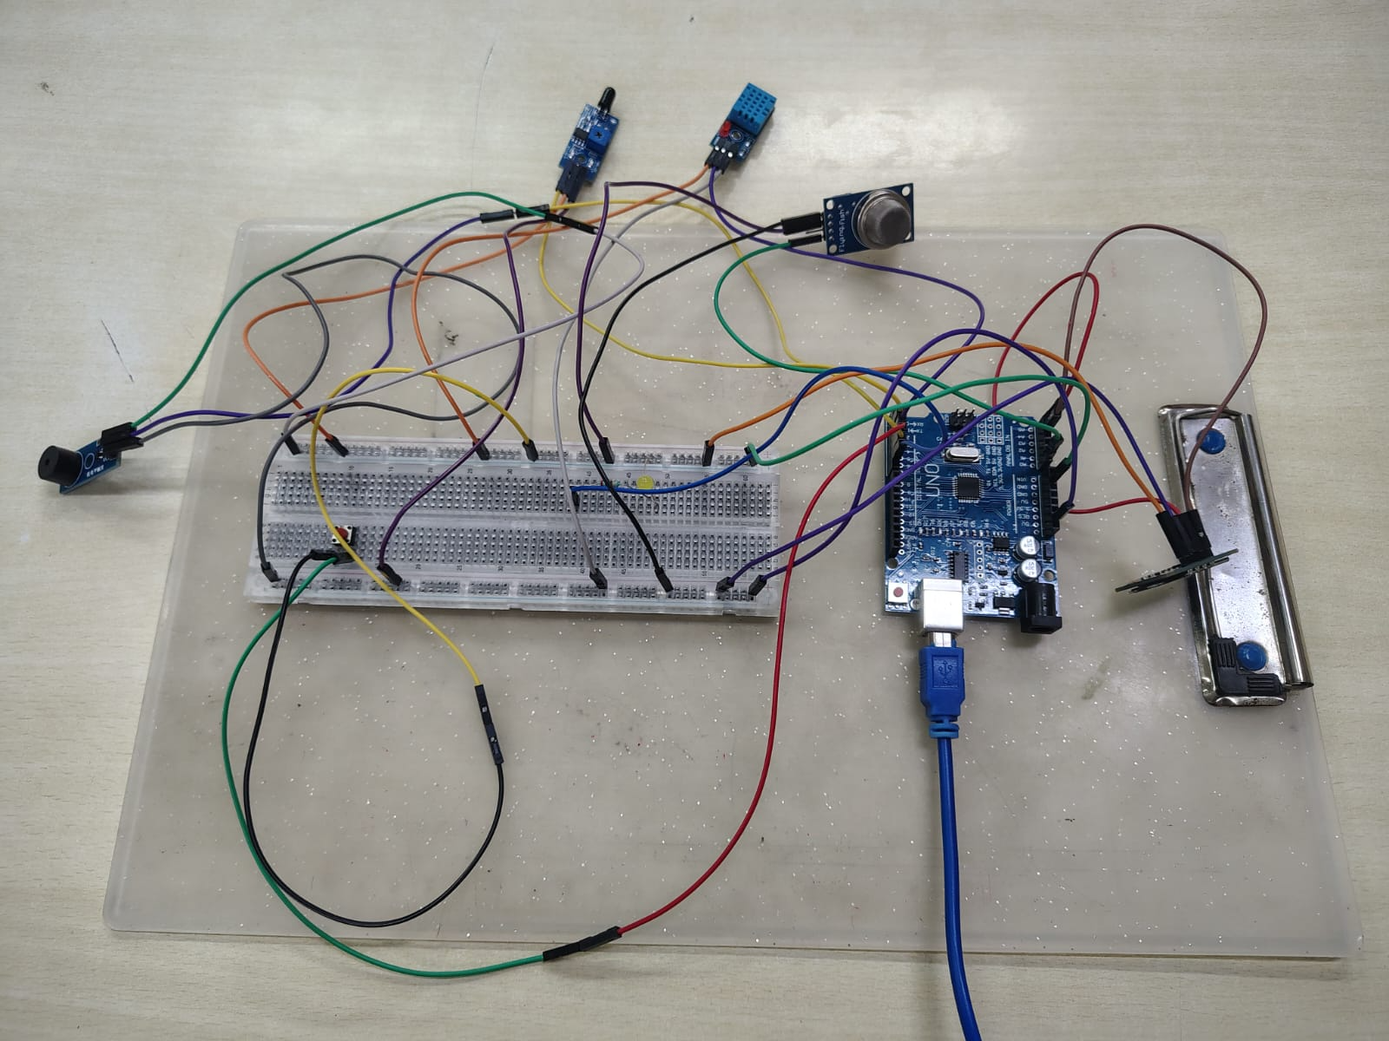
Fig3.Prototye Model

Discussion
The experimental results confirm that the prototype is capable of reliably detecting early warning signs of thermal runaway and responding autonomously without requiring human intervention. This is an important feature for safety-critical systems, as it reduces reliance on user awareness and ensures immediate action.

The response time achieved was suitable for a prototype-level demonstration. However, in a production environment, further improvements could be made:
- Sensor calibration to improve accuracy and reduce false positives.
- Faster polling intervals to shorten detection and reaction time.
- Integration of wireless communication modules (e.g., ESP8266 or GSM) to enable remote monitoring and alerts, which would make the system more practical for real-world deployment.

Another important observation is that the system maintained robust access control through button. This feature not only prevents unauthorized charging but also adds an extra layer of safety by ensuring that only approved users can operate the system.

Overall, the prototype demonstrates that combining multiple sensors (gas, flame, temperature, humidity) with relay control and user authentication can create a multi-layered safety mechanism. While the current version is limited to local alerts, the foundation is strong enough to be expanded into a fully networked safety system with cloud-based monitoring and predictive analytics.

6. Conclusions and Future Scope

6.1 Conclusion
This project successfully demonstrates a functional, low-cost prototype for an automated Smart EV Charging Bay Safety System. Built around an Arduino controller, the system directly addresses a major safety concern in electric vehicle adoption: the risk of catastrophic battery fires caused by thermal runaway during charging cycles.

Project Summary

- Access Control: Power delivery is completely isolated by default and is only enabled when a person presses button.
- Multi-Sensor Safeguards: The charging bay continuously scans for early environmental warning signs of battery failure, including combustible gas emissions (MQ sensor), general chemical off-gassing (MQ135), infrared radiation (flame sensor), and heat buildup (DHT11).
- Automated Isolation: The moment any sensor detects a value beyond its calibrated safety threshold, the system triggers an emergency override—instantly disengaging the primary charging relay, activating a high-frequency audible buzzer, and printing an urgent warning message on the local OLED screen.

By shifting safety monitoring from the vehicle’s internal management system to the stationary charging bay itself, this design offers a universal, budget-friendly safety net that operates independently of the vehicle model being charged.

6.2 Future Scope
Future Scope
While this prototype successfully validates the physical hardware logic, real-world deployment across municipal and commercial EV charging stations can be expanded through the following research and engineering directions:
- IoT Cloud Telemetry & Mobile Alerts: Transitioning from local Arduino microcode to an IoT-enabled microcontroller (such as the ESP32 or NodeMCU) will allow real-time sensor streams to be uploaded to cloud dashboards like ThingSpeak or AWS IoT. This enables operators to receive instant SMS or push notifications during an emergency for remote site monitoring, building upon research by Patil et al. (2023) in "IoT-Based Battery Monitoring System for Electric Vehicles," which demonstrated that cloud data logging provides proactive maintenance alerts to prevent catastrophic thermal runaway.
- Machine Learning for Predictive Thermal Warning: Instead of relying strictly on fixed, hardcoded thresholds, future iterations can run predictive machine learning models, such as LSTM networks, to detect non-linear temperature spikes before physical safety limits are breached. This approach aligns with findings from a study published in Nature Scientific Reports (2025) titled "Early warning method for charging thermal runaway of electric vehicle lithium-ion battery based on charging network," which proved that temperature-prediction models can calculate residual thermal shifts during fast charging to issue pre-warning alerts long before runaway occurs.
- Integration of Direct Battery Internal Strain Sensing: The safety layer can expand beyond external atmospheric gas and flame sensors by embedding passive, battery-free sensors inside the battery enclosure to detect physical cell swelling during initial charging cycles. As demonstrated by research in IEEE Transactions (2024) on "UHF RFID-Based Battery-Free Wireless Strain Sensors for EV Battery Management Systems," passive RFID tags can monitor mechanical cell expansion inside metallic battery cases, allowing safety systems to catch structural battery deformation before off-gassing even begins.
- Direct BMS & VCU Interoperability: Interfacing the charging bay controller directly with the vehicle's onboard Vehicle Control Unit (VCU) or Battery Management System (BMS) over the CAN Bus protocol enables the station to compare internal cell voltage drop metrics directly against bay atmospheric data. This cross-verification reduces false alarms and ensures a coordinated, simultaneous power shutdown between both the vehicle and the grid charger during a fault.
- Multi-Bay Scalability & Automated Suppression: The central architecture can be scaled to manage multiple charging spots simultaneously across commercial parking garages or public hubs. Integrating this network with automated localized fire suppression hardware, such as aerosol fire extinguishers or sprinkler actuators, would transform the standalone safety module into a comprehensive, multi-bay emergency mitigation infrastructure.

References

- Teng, Z. and Lv, C., 2025. Detection toward early-stage thermal runaway gases of Li-ion battery by semiconductor sensor. Frontiers in Chemistry, 13, p.1586903.

- Cherifi, M., 2026. Autonomous Edge-Deployed AI Agents for Electric Vehicle Charging Infrastructure Management. arXiv preprint arXiv:2603.08736..

- Xie, Z., Zhang, Y., Wang, H., Li, P., Shi, J., Zhang, X. and Li, S., 2024. The multi-parameter fusion early warning method for lithium battery thermal runaway based on cloud model and dempster–shafer evidence theory. Batteries, 10(9), p.325.

- Xu, J., Pan, J., Cui, T., Zhang, S., Yang, Y. and Ren, T.L., 2023. Recent Progress of Tactile and Force Sensors for Human–Machine Interaction. Sensors, 23(4), p.1868.

- Nam, H., Seol, K.H., Lee, J., Cho, H. and Jung, S.W., 2021. Review of capacitive touchscreen technologies: Overview, research trends, and machine learning approaches. Sensors, 21(14), p.4776.Patil, S., Kumar, A., and Prabakaran, R. (2023) ‘IoT-Based Battery Monitoring System for Electric Vehicles’, International Journal of Engineering and Research Technology, 15(3), pp. 82–89.

- Gao, D., Zhang, Y., Wang, L., and Liu, H. (2025) ‘Early warning method for charging thermal runaway of electric vehicle lithium-ion battery based on charging network’, Nature Scientific Reports, 15(1), p. 92738.

- Muneer, B., and Palazzi, V. (2024) ‘UHF RFID-Based Battery-Free Wireless Strain Sensors for EV Battery Management Systems’, IEEE Transactions on Vehicular Technology / ResearchGate.

- Zhao, C., Sun, X., Zhang, W., and Wang, Y. (2022) ‘Review of the Charging Safety and Charging Safety Protection of Electric Vehicles’, Journal of Advanced Transportation / MDPI, 12(4), pp. 184–198.

Appendices

Datasheet:

Component Name | Operating Voltage | Signal / Interface Type | Key Operating Range / Sensitivity | Primary Function in System
Arduino Uno R3 | $5\text{V DC}$ (USB/7–12V Vin) | Digital, Analog, $I^{2}C$, UART | $16\text{ MHz}$ ATmega328P Clock Speed | Central Processing Unit; executes system logic, processes sensor data, and controls outputs.
MQ-135 Gas Sensor | $$5\text{V DC}$$ | Analog Output ($0-5\text{V}$) & Digital Output | $10\text{–}1000\text{ ppm}$ (NH3, Benzene, Smoke, CO2) | Detects hazardous atmospheric chemical emissions and toxic off-gassing near the EV battery.
IR Flame Sensor Module | $$3.3\text{V – }5\text{V DC}$$ | Digital (DO) / Analog (AO) | $760\text{ nm – }1100\text{ nm}$ IR Wavelength; ${60}^{∘}$ Detection Angle | Detects the presence of open flames via infrared light radiation.
DHT11 Sensor | $$3.3\text{V – }5.5\text{V DC}$$ | Single-bus Digital Signal | $temp:0\text{–}{50}^{∘}\text{C}\text{(}±2^{∘}\text{C}$ accuracy)  Humidity: $20\text{–}90\%\text{ RH}$ | Monitors ambient temperature and humidity levels inside the charging bay to detect heat buildup.
0.96" OLED Display (SH1106 / SSD1306) | $$3.3\text{V – }5\text{V DC}$$ | $I^{2}C$ Interface (Address 0x3C) | $128×64$ Resolution | Provides real-time visual feedback, system status messages, and diagnostic telemetry readings.
Active Buzzer | $$3.3\text{V – }5\text{V DC}$$ | Digital Output | $≈2.3\text{ kHz}$ Frequency Tone Output | Emits a high-frequency audible warning alarm when a critical thermal hazard occurs.
Red LED | $$1.8\text{V – }2.2\text{V DC}$$ | Analog / Digital Driven | Forward Current: $20\text{ mA}$ | Visual state indicator representing power delivery / active charging status (CHARGE_LED_PIN).
$220 Ω$ Resistor | N/A | Passive Linear Component | Resistance: $220 Ω±5\%$ ($1/4\text{W}$) | Current-limiting resistor connected in series with the Red LED to prevent pin overcurrent.
Push Button | Up to $12\text{V DC}$ | Digital Input (INPUT_PULLUP) | Momentary SPST Contact Switch | Manual user control interface used to start/stop charging sessions or reset active hazard alarms.
Solderless Breadboard | N/A | Mechanical Circuit Board | Standard 830 / 400 Tie-Point Grid | Provides temporary, solderless electrical connections between components during prototyping.
Jumper Wires | N/A | Conductor Wire | Male-to-Male, Male-to-Female, Female-to-Female | Interconnects sensor pins, actuators, and power rails directly to the Arduino Uno pins.

